**USER GUIDE**

# INTRODUCTION

Welcome to the Pickup Line App! This application is designed to provide users with a selection of pickup lines for different situations. The user-friendly interface offers a wide range of clever, flirty, and romantic pickup lines to suit your style.

# PURPOSE OF THE USER GUIDE

The aim of this user guide is to assist users in effectively using the Pickup Line App. It offers instructions on navigating the app's features, accessing different categories of pickup lines, and entering new pickup lines into the database. By following this guide, users can enhance their experience with the app and discover new and exciting pickup lines to use in various social settings.

# PREREQUISITES AND REQUIREMENTS

To use the Pickup Line App, you need:

* A device (a computer) running the Python programming language.
* The necessary Python libraries installed, including Tkinter, ttkbootstrap.
* Basic knowledge of how to navigate through a graphical user interface (GUI) application.
* An internet connection to install the dependencies

With these requirements fulfilled, you are now prepared to explore the realm of pickup lines and inject some amusement into your conversations!

# GETTING STARTED

## Installations Instruction

### Windows:

* Visit the Python website (https://www.python.org/) and download the latest version of Python for Windows.
* Run the installer and follow the on-screen instructions to install Python on your computer.
* Download the Pickup Line App source code from the provided link.
* Extract the contents of the downloaded zip file to a folder on your computer.
* Navigate to your folder and open the Command Prompt or PowerShell in that location.
* Open Command Prompt or PowerShell. In the **requirements.txt** you will see the list of dependencies needed and use the **pip** command to install the required libraries.

pip install ttkbootstrap (tkkbootstrap is the name of the dependency. Do the same for the rest)

* Now run **python main.py** to run the app

### Initial Setup:

After installing the app, there is no need for additional setup steps. Simply launch the app and access the main interface to start exploring pickup lines. If you wish to contribute your own pickup lines to the app's database, navigate to the 'Enter Line' tab and follow the instructions provided. Enjoy using the Pickup Line App!

# User Interface Overview:

The Pickup Line App has a user-friendly interface that provides easy access to a variety of pickup lines. The main components of the app are:

1. The Main Tab:

* This displays a randomly selected pickup line at the center of the screen.
* Users can navigate through the pickup lines using the 'Previous' and 'Next' buttons located at the bottom of the tab.
* A dropdown menu allows users to select a specific category of pickup lines, such as 'Funny,' 'Flirty,' or 'Clever.'
* Clicking the 'Get random [category]' button generates a random pickup line from the selected category.

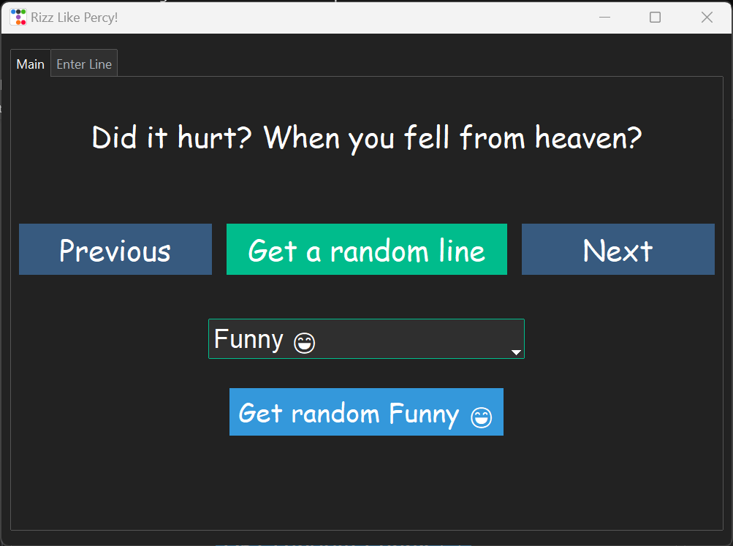

1. The Navigation Buttons

* The navigation buttons are located at the bottom of the main tab and allow users to move between pickup lines.
* The 'Previous' button displays the previous pickup line in the app's history,
* while the 'Next' button displays the next pickup line in the app's history.
* The “Get a random line” gives a random line

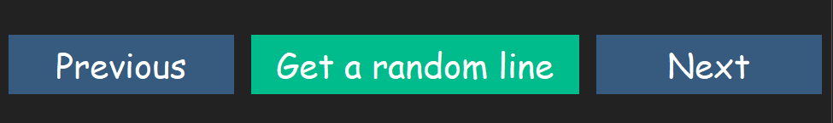

1. The Category Selection

* In the main tab, users have the option to select a specific category of pickup lines from a dropdown menu.
* The available categories are 'Funny', 'Flirty', 'Clever', 'Romantic', 'Complementary', and 'Cheesy'.

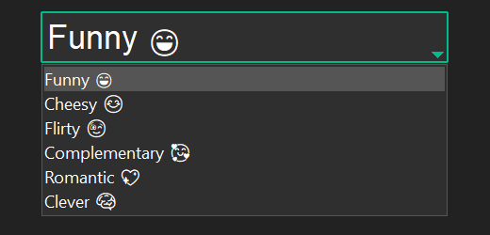

1. The 'Enter Line' tab

* It enables users to add their own pickup lines to the app's database.
* Users can input the language, category, and text of their pickup line into the respective fields.
* Once the 'Submit' button is clicked, the entered pickup line is saved into the app's database for future use.

